1. Rewrite the following code using a ternary operator:  
let result;  
if (score >= 80) {  
    result = "Pass";  
} else {  
    result = "Fail";  
}

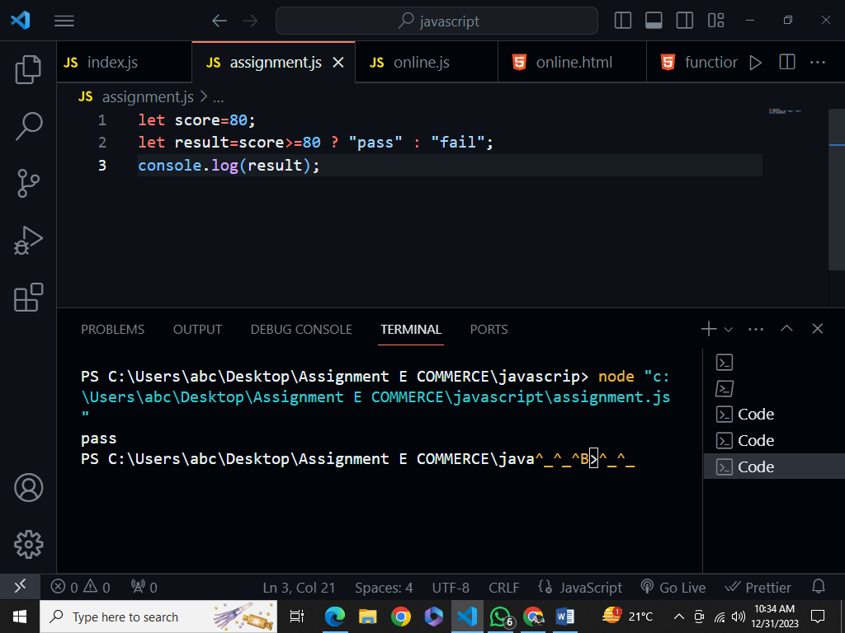

2. How does the optional chaining operator (?.) work, and how can it be used to access nested properties of an object?

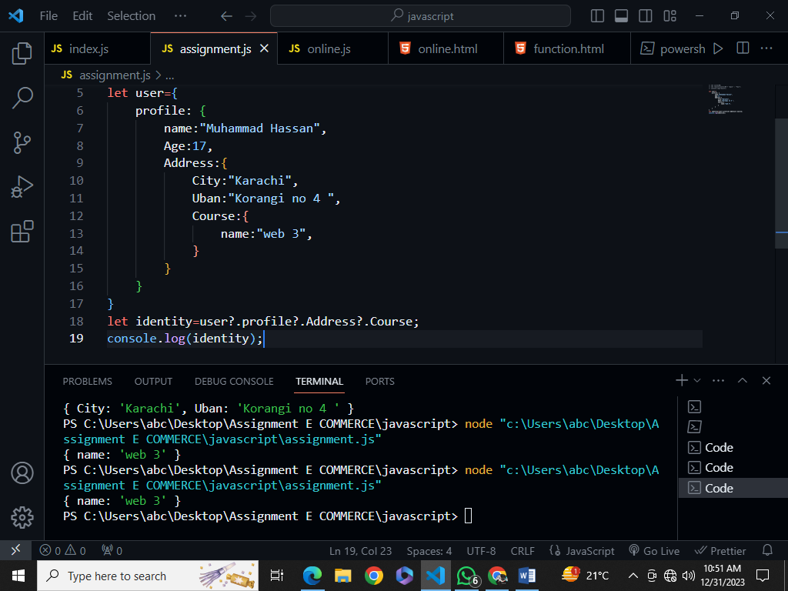

3. Compare the for...in loop and the for...of loop in terms of their use cases and the types of values they iterate over.

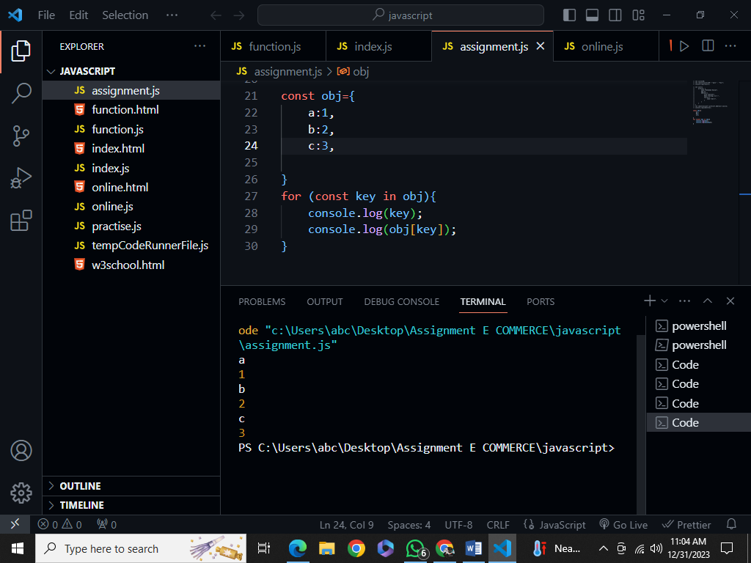

4. Define a function calculateAverage that takes an array of numbers as an argument and returns the average value.

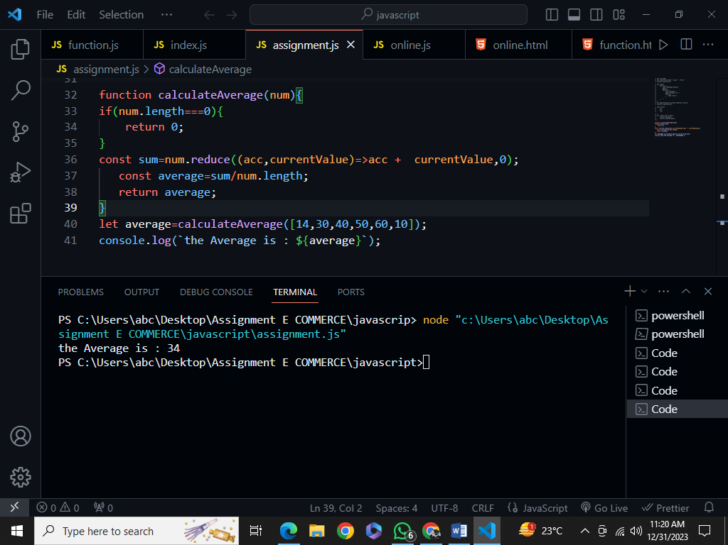

5. Explain the concept of "closures" in JavaScript and provide an example of their practical use.

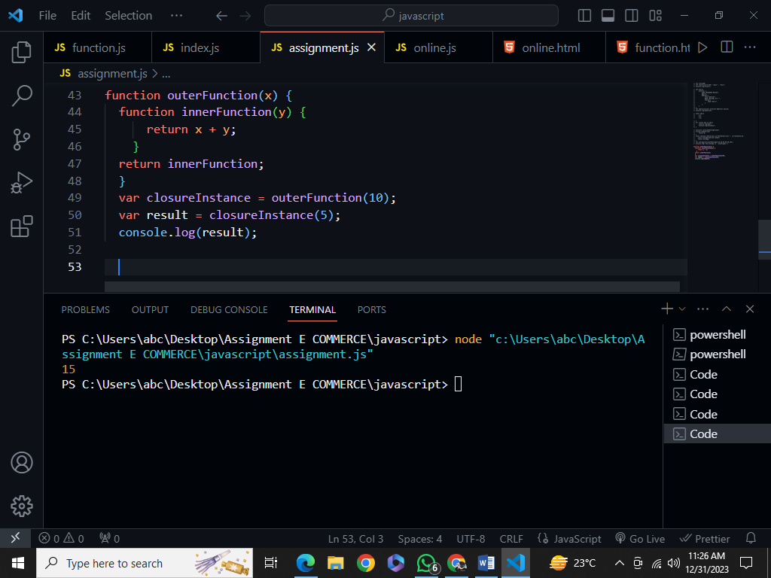

6. Create an object named student with properties name, age, and grades. Add a method calculateAverage that calculates the average of the grades.

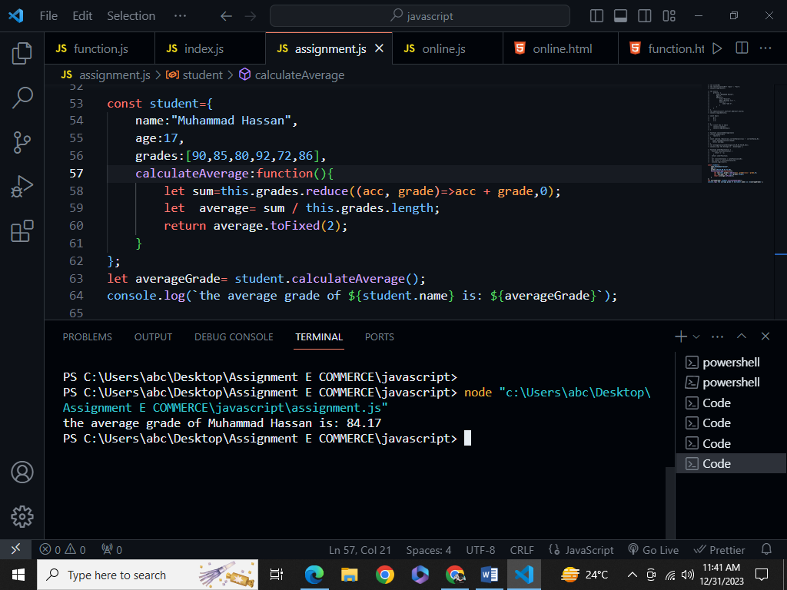

7. How can you clone an object in JavaScript and also give one example each deep copy, shallow copy, and reference copy

Shallow Copy

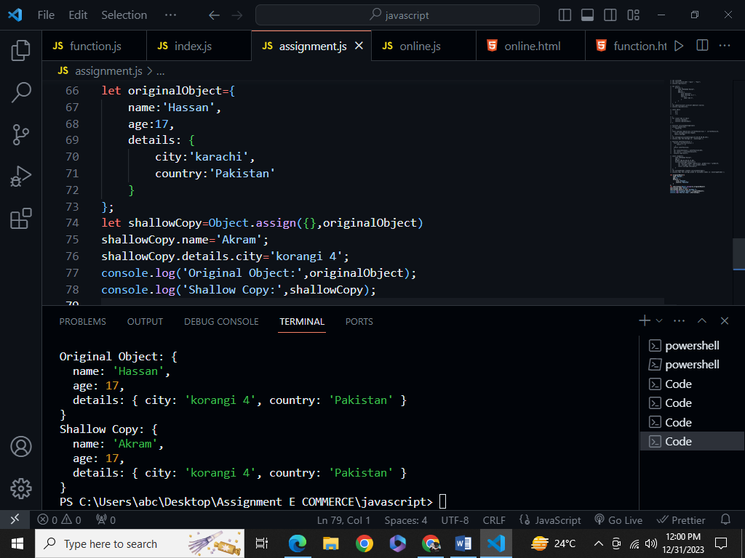

Deep Copy

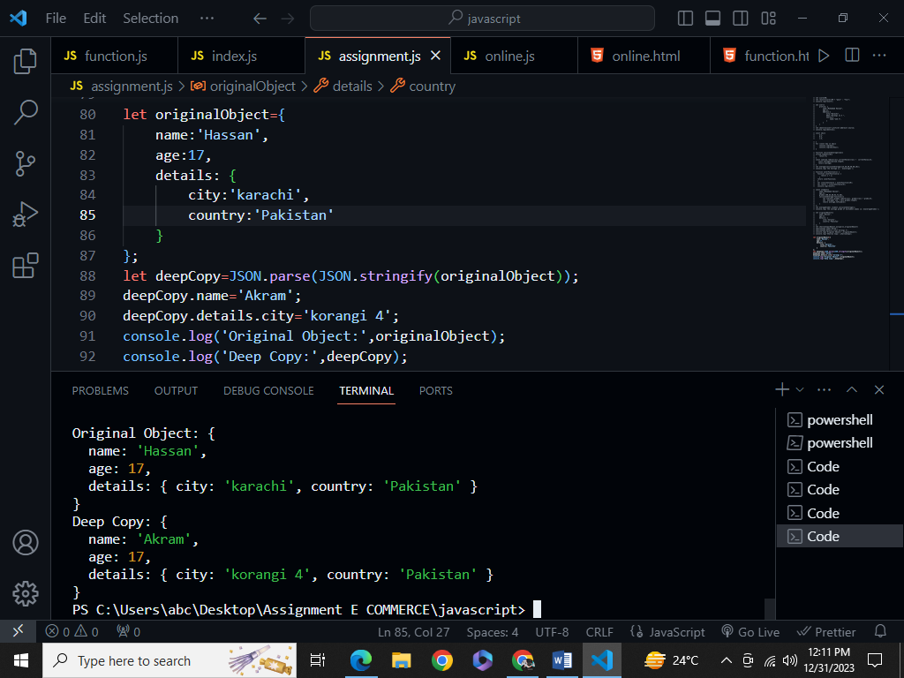

Reference Copy

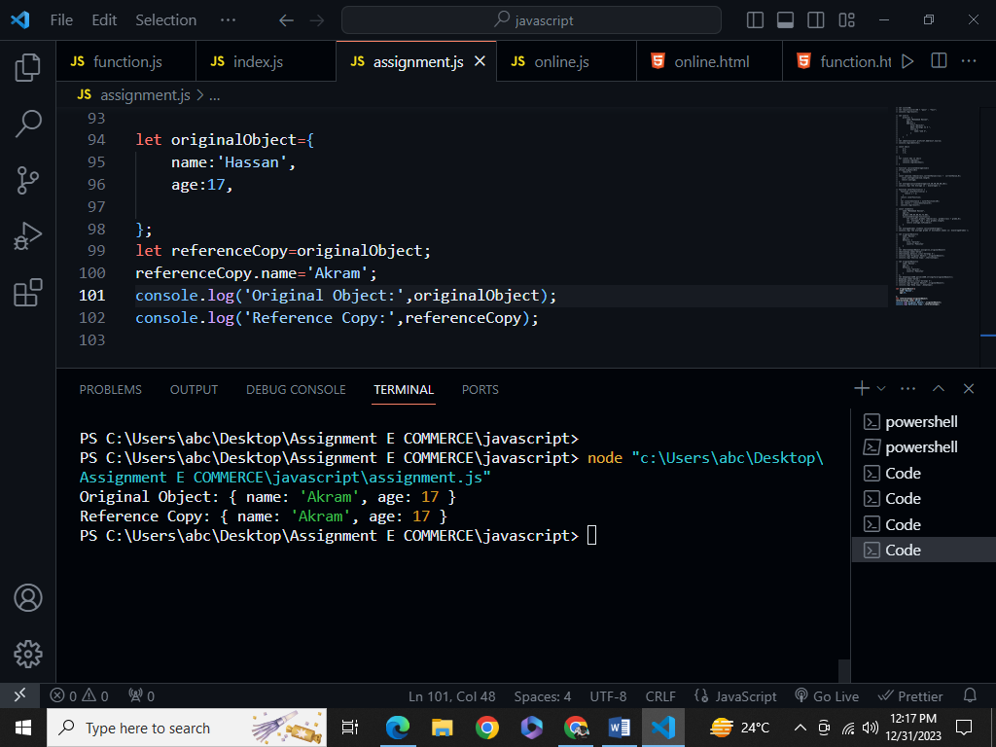

8. Write a loop that iterates over an array of numbers and logs whether each number is even or odd, using a ternary operator.

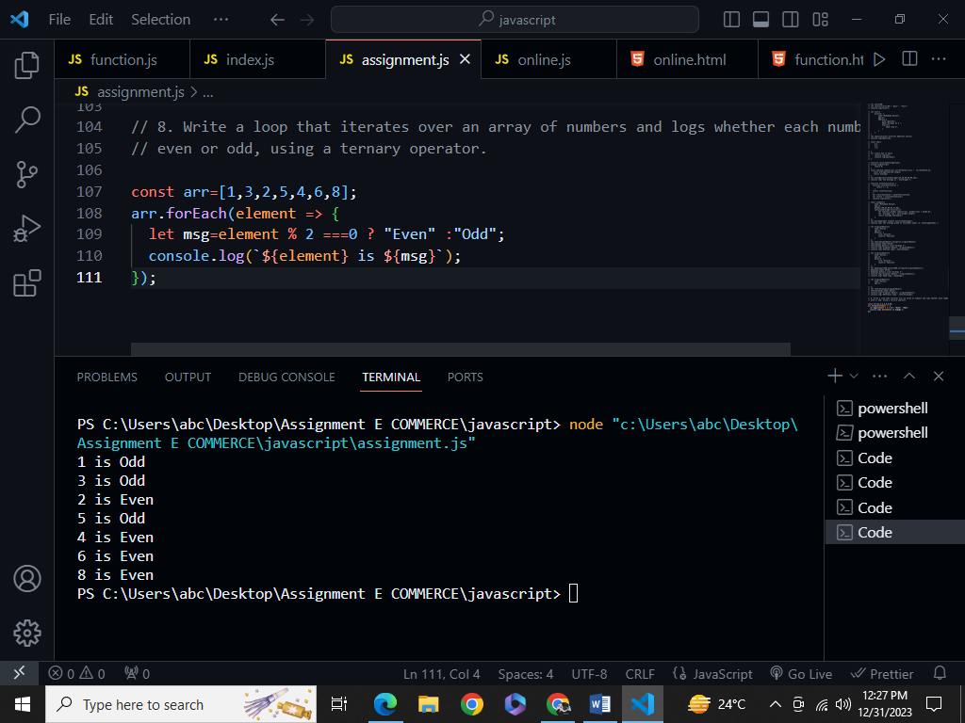

9. Describe the differences between the for loop, while loop, and do...while loop in JavaScript. When might you use each?

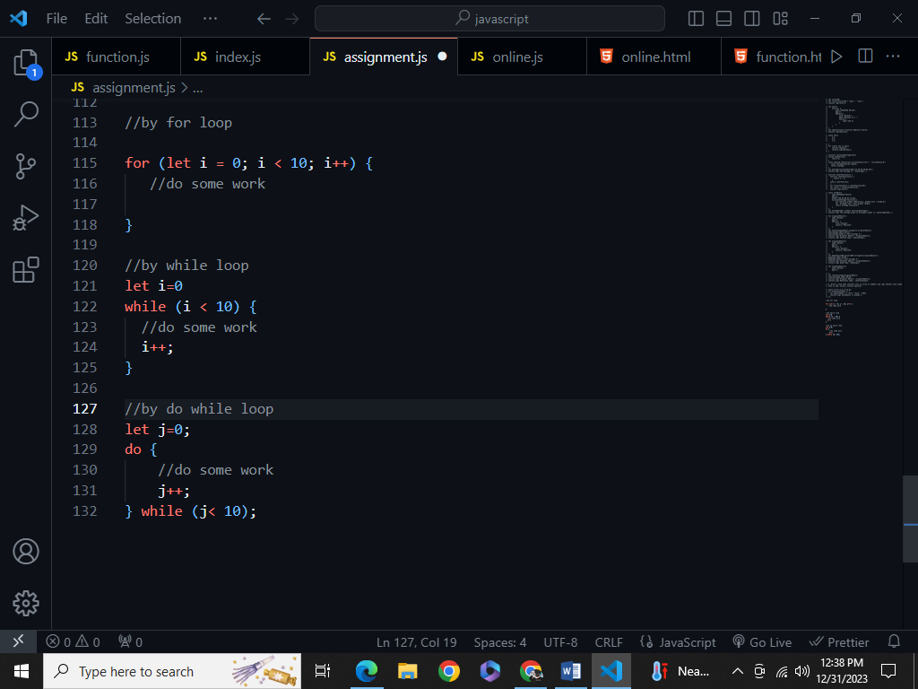

10. Provide an example of using optional chaining within a loop to access a potentially missing property of an object.

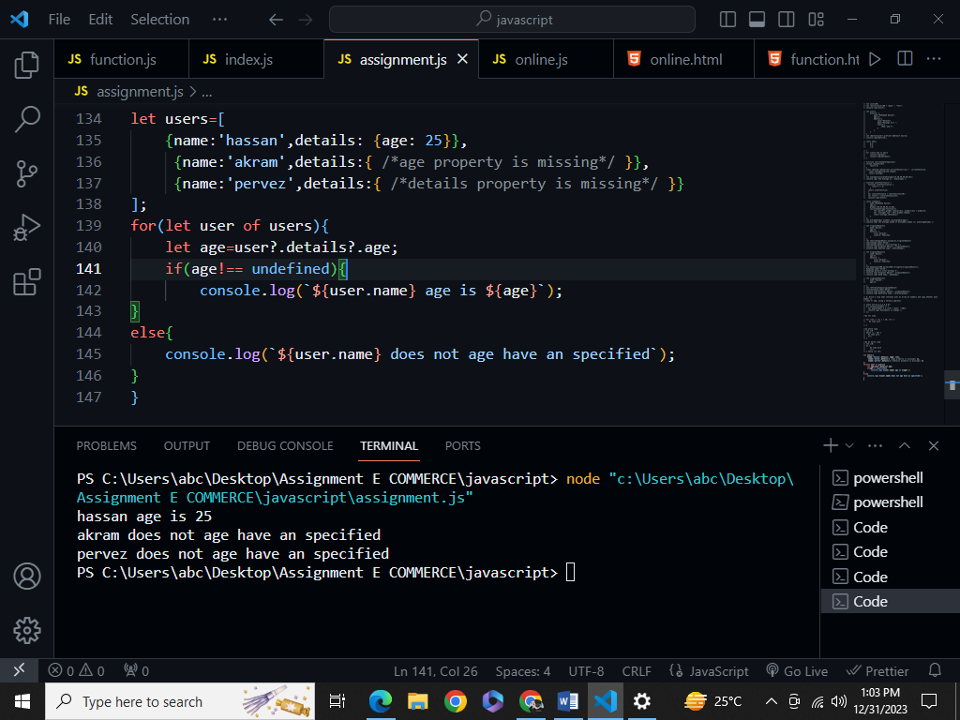

11. Write a for...in loop that iterates over the properties of an object and logs each property name and value.

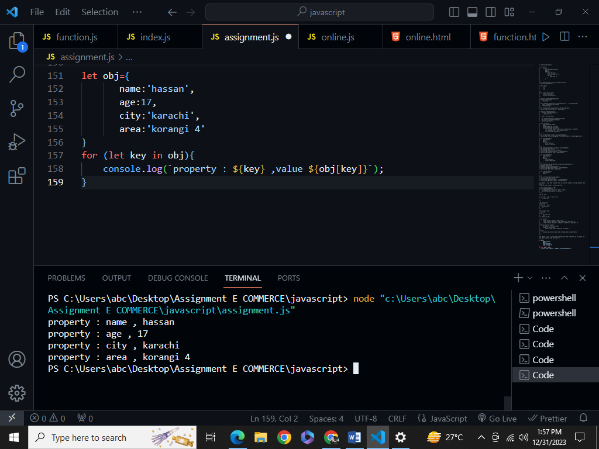

12. Explain the use of the break and continue statements within loops. Provide scenarios where each might be used.

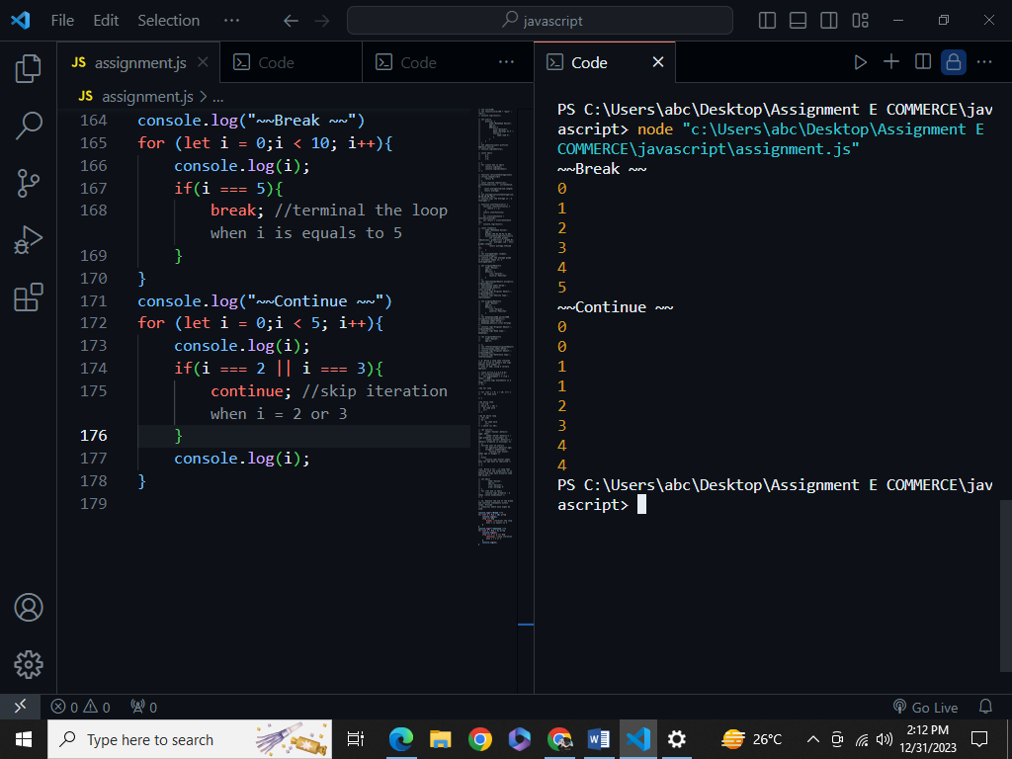

13. Write a function calculateTax that calculates and returns the tax amount based on a given income. Use a ternary operator to determine the tax rate.

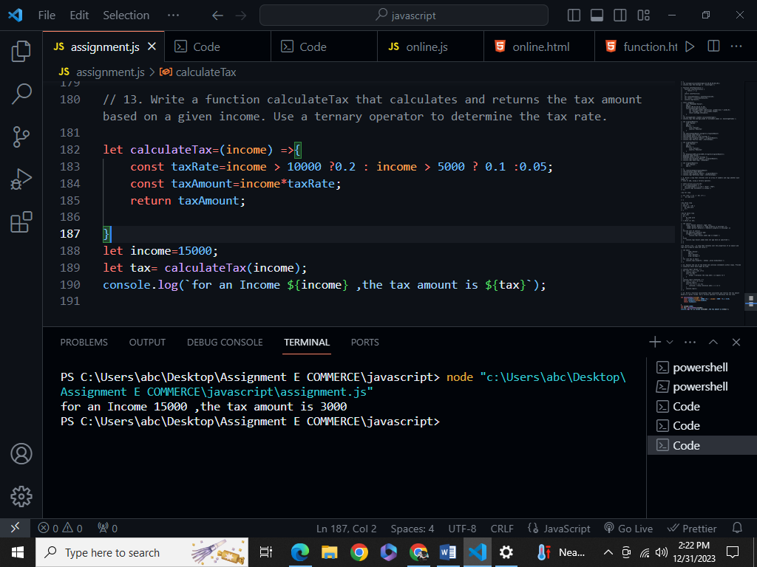

14. Create an object car with properties make, model, and a method startEngine that logs a message. Instantiate the object and call the method.

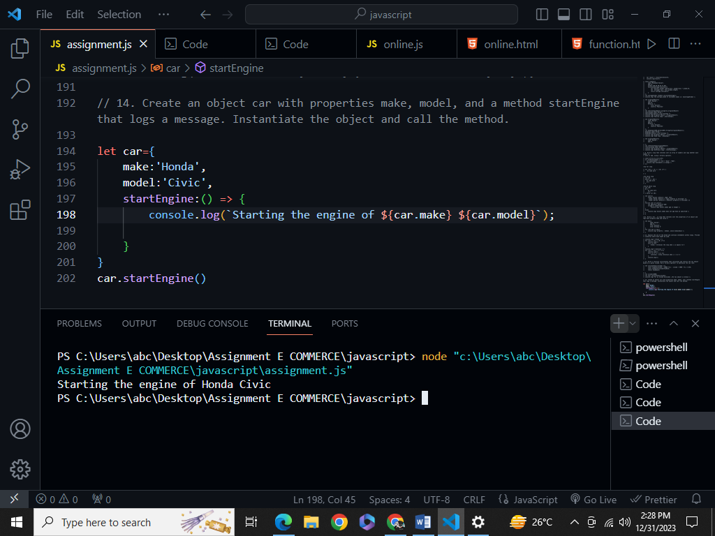

15. Explain the differences between regular functions and arrow functions in terms of scope, this binding, and their use as methods.

Regular Functions:

Scope:

● Regular functions have their own this context.

● They have their own arguments object and super keyword.

● The this context within a regular function depends on how the function is called.

Use as Methods:

● Regular functions can be used as methods within objects.

● They have their own this context, which can be useful when defining behavior specific to that object.

Arrow Functions:

Scope:

● Arrow functions do not have their own this context.

● They do not have their own arguments, super, or new. target bindings.

● They inherit this from the surrounding lexical context where they are defined.

Use as Methods:

● Arrow functions are not suitable for use as methods within objects that need to access their own this context.

● They are commonly used within callbacks, event handlers, or in situations where you want to maintain the surrounding this context